YEAR 12 CHEMISTRY ATCHE

TEST 3 2021

Redox reactions, Electrochemical cells,
Corrosion

MULTIPLE CHOICE QUESTION BOOKLET

Part 1: Multiple choice style consisting of TEN (10) questions.
Each question is worth 1 mark.
Write your answers on the Multiple-choice Answer Sheet provided.

PART 1 – MULTIPLE CHOICE (10 MARKS)

- Which one of the following species listed below contains sulfur with the lowest oxidation state?

A. SO₃
B. SO₂
C. (NH₄)₂S
D. H₂SO₄

- Which one of the following is not a redox reaction?

- Mg(s) + 2 H⁺(aq) → Mg²⁺(aq) + H₂(g)
B. Ag+(aq) + I–(aq) AgI(s)
C. 2 Ag⁺(aq) + Zn(s) → 2 Ag(s) + Zn²⁺(aq)
D. Cl₂(g) + 2 I–(aq) → 2 Cl–(aq) + I₂(s)

- What is the value of “x” in the equation below?

x Fe ²⁺ (aq) + _H ⁺ (aq) + _O₂ (g) _Fe ³⁺ (aq) + _H₂O (l)

- 1
- 2
- 4
- 5

- Regarding the corrosion of iron, which of the following statements is not correct?

- The solid Fe loses electrons.
- The oxidation number of O₂ is decreased.
- The precipitation of Fe(OH)₂ by combination of iron(ii) ions with hydroxide is not a redox process.
- The H₂O acts as the oxidising agent.

- Which of the following salts cannot be prepared by the reaction of a metal and a dilute acid?

A. Copper(II) sulfate
B. Iron(II) chloride
C. Nickel(II) chloride
D. Magnesium sulfate

- Which one of the following halogen displacement reactions would not occur under standard conditions?

- Br_{2(aq)} + KCl_{(aq)}

- Br_{2(aq)} + KI_{(aq)}

- Cl₂(aq) + KBr(aq)

- Cl₂(aq) + KI(aq)

Question 7 refers to the diagram and the equations below.
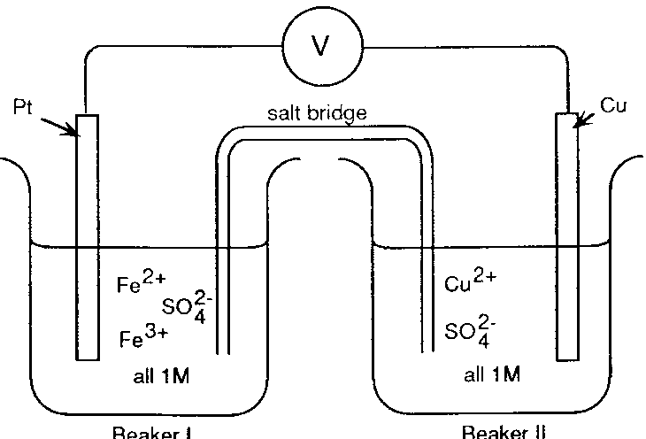
BEAKER I
BEAKER II

Note:
M = molL⁻¹

Fe³⁺ + e‾ Fe²⁺ E⁰ = 0.77 V
Cu²⁺ + 2e‾ Cu E⁰ = 0.34 V

- If the salt bridge contained KNO₃ solution, the:
  - K⁺ ions move from beaker I and are replaced by Cu²⁺ ions.
  - NO₃‾ ions migrate into beaker I and are replaced by SO₄²‾ ions from beaker II.

  - K+ ions move into beaker II and NO₃‾ ions move into beaker I.
  - K⁺ ions move into beaker I and NO₃‾ ions move into beaker II.

- In the electrolysis of a solution of copper(II) sulfate using inert electrodes, what will happen to the pH of the solution as the reaction proceeds?
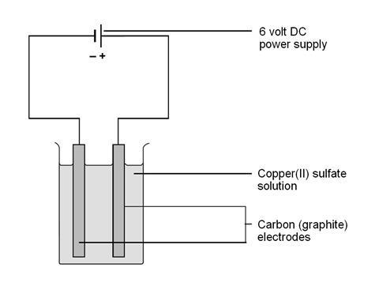
- Increase.
- Decrease.
- Increase and then decrease.
- No change

- Which of the following factors contribute to increasing the rate of the corrosion of iron?

- Increased air pressure
- Increased temperature
- Increased acidity
- Increased humidity

- 1 only
- 1 and 4 only
- 1, 2 and 4 only
- 1, 2, 3 and 4

- Four metals Pb, x, y and z, were connected in pairs and the voltage was recorded.

The results obtained are set out in the table below. List the metals from weakest to the strongest reductant.

Negative terminal | Positive terminal | Voltage (V)
Pb | x | 0.35
y | Pb | 1.10
z | Pb | 2.60

A. z, y, Pb, x

B. Pb, x, y, z

C. x, y, Pb, z

D. x, Pb, y, z

End of Multiple-choice Questions

